**DAILY ONLINE ACTIVITIES SUMMARY**

|  |  |  |  |  |  |  |  |  |
| --- | --- | --- | --- | --- | --- | --- | --- | --- |
| **Date:** | **22/05/2020** | | | | | **Name:** | **Sheetal** | |
| **Sem & Sec** | **8 B** | | | | | **USN:** | **4AL16CS091** | |
| **Online Test Summary** | | | | | | | | |
| **Subject** | | **BDA** | | | | | | |
| **Max. Marks** | | **40** | | **Score** | | | **31** | |
| **Certification Course Summary(Internship)** | | | | | | | | |
| **Task** | **Study-Learning data analytics concepts with platform specified**  **POC-Embedded cooncept. Worked on integration of dashboard with website** | | | | | | | |
| **company** | | | **Gain-insights** | | **Duration** | | | **9 hr** |
| **Coding Challenges** | | | | | | | | |
| **Problem Statement:**  **1) Write a program to rotate the array to the right by k steps where k is a nonnegative.** | | | | | | | | |
| **Status:completed** | | | | | | | | |
| **Uploaded the report in Github** | | | | | **Yes** | | | |
| **If yes Repository name** | | | | | [alvas-education-foundation](https://github.com/alvas-education-foundation)/ **[sheetal-shettigar](https://github.com/alvas-education-foundation/sheetal-shettigar)** | | | |
| **Uploaded the report in slack** | | | | | **Yes** | | | |

ONLINE TEST:

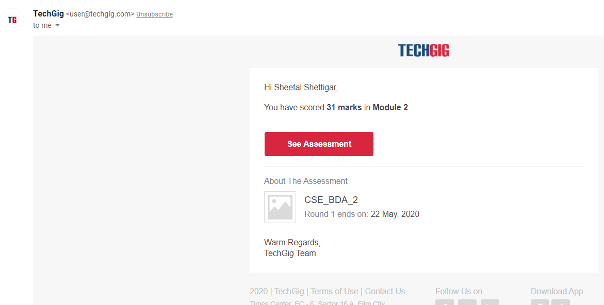

CODING CHALLENGE:

PROGRAM 1 :  
#include <stdio.h>

void rightRotate(int A[], int k, int n)

{

int aux[k];

for (int i = 0; i < k; i++)

aux[i] = A[n-k+i];

for (int i = n-k-1; i >= 0; i--)A[i+k] = A[i];

for (int i = 0; i < k; i++)

A[i] = aux[i];

}

int main(void)

{

int A[] = { -1,-100,3,99 };

int k = 2;

int n = sizeof(A)/sizeof(A[0]);

rightRotate(A, k, n);

for (int i = 0; i < n; i++)

printf("%d ", A[i]);

return 0;

}